DAY 4 -ASSIGNMENT

-- 1. List all customers and the products they ordered with the order date. (Inner join)

-- Tables used: customers, orders, order_details, products

-- Output should have below columns:

-- companyname AS customer,

-- orderid,

-- productname,

-- quantity,

-- orderdate

SELECT * FROM CUSTOMERS

SELECT * FROM ORDERS

SELECT * FROM ORDER_DETAILS

SELECT * FROM PRODUCTS

-------Query to get common columns from multiple tables--------------

SELECT column_name

FROM INFORMATION_SCHEMA.COLUMNS

WHERE table_name IN ( 'products','order_details')

GROUP BY column_name

HAVING COUNT(DISTINCT table_name) > 1;

SELECT company_name AS customer, o.order_id,p.product_name, od.quantity, o.order_date

-----------------------------------

FROM customers

INNER JOIN orders o

ON o.customer_id = customers.customer_id

INNER JOIN order_details od

ON od.order_id=o.order_id

INNER JOIN products p

ON p.product_id=od.product_id

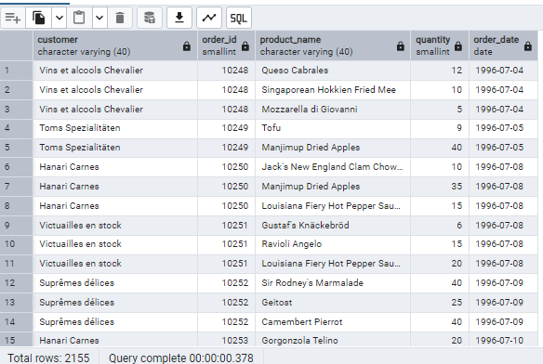

================================================

-- 2. Show each order with customer, employee, shipper, and product info — even if some parts are missing. (Left Join)

-- Tables used: orders, customers, employees, shippers, order_details, products

SELECT * FROM shippers

SELECT * FROM order_details

SELECT o.order_id,

c.company_name AS customer,

e.first_name || ' ' || e.last_name AS employee,

s.company_name AS shipper,

p.product_name,

od.quantity,

o.order_date FROM orders o

LEFT JOIN customers c

ON c.customer_id = o.customer_id

LEFT JOIN employees e

ON o.employee_id= e.employee_id

LEFT JOIN shippers s

ON o.ship_via=s.shipper_id

LEFT JOIN order_details od

ON o.order_id=od.order_id

LEFT JOIN products p

ON od.product_id= p.product_id

================================================

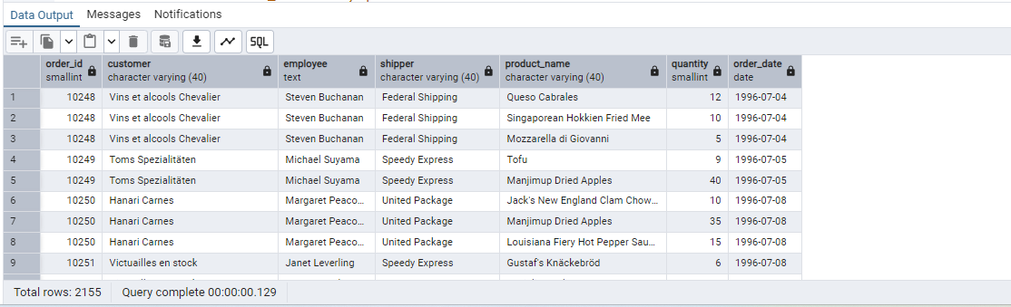

-- 3. Show all order details and products (include all products even if they were never ordered). (Right Join)

-- Tables used: order_details, products

-- Output should have below columns:

-- orderid,

-- productid,

-- quantity,

-- productname

SELECT order_id,

p.product_id,

quantity,

p.product_name

FROM order_details od

RIGHT JOIN products p

ON p.product_id= od.product_id

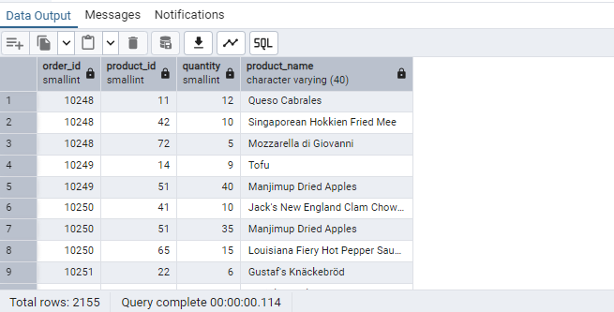

-- 4. List all product categories and their products — including categories that have no products, and products that are not assigned to any category.(Outer Join)

-- Tables used: categories, products

select * from categories

select * from products

SELECT c.category_id,c. category_name,p.product_id, p.product_name

FROM products p

FULL OUTER JOIN categories c

ON c.category_id= p.category_id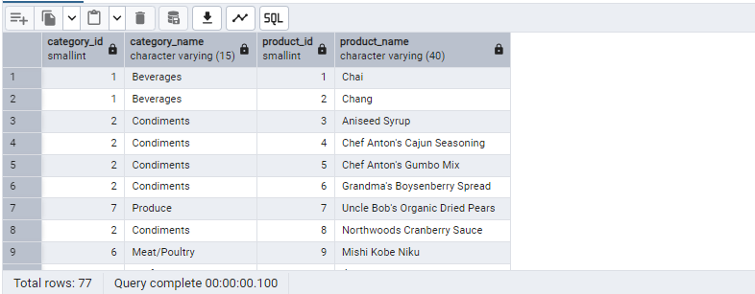

-- 5. Show all possible product and category combinations (Cross join).

------ cross join-----

-- It multiplies the rows of the first table with the rows of the second table.

-- It does not require any condition (like ON or USING).

-------Query to get common columns from multiple tables--------------

SELECT column_name

FROM INFORMATION_SCHEMA.COLUMNS

WHERE table_name IN ( 'categories','products')

GROUP BY column_name

HAVING COUNT(DISTINCT table_name) > 1;

select * from categories

Main quary:

SELECT * FROM products p

CROSS JOIN categories c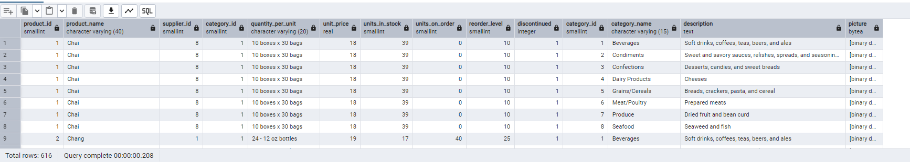

-- 6. Show all employees and their manager(Self join(left join))

select * from employees

SELECT e.employee_id,

e.first_name ||' '|| e.last_name as Employee_name, m.employee_id AS manager_id,

m.first_name ||' '|| m.last_name as Manager_name

FROM employees e

LEFT JOIN employees m

ON m.employee_id= e.reports_to

e.employee_id;

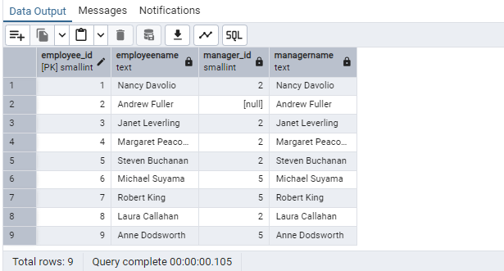

-- 7. List all customers who have not selected a shipping method.

-- Tables used: customers, orders

-- (Left Join, WHERE o.shipvia IS NULL)

select * from customers

select * from orders

SELECT c.customer_id FROM customers c

LEFT JOIN orders o

ON c.customer_id= o.customer_id

WHERE ship_via IS NULL

